A PROJECT ON

“Vehicle Collision Severity Prediction”
SUBMITTED IN
PARTIAL FULFILLMENT OF THE REQUIREMENT FOR THE COURSE OF
DIPLOMA IN BIG DATA ANALYSIS



SUNBEAM INSTITUTE OF INFORMATION TECHNOLOGY, PUNE
Submitted By:

Aqib Shaikh (80426)

Tanzeel Mansuri (80435)

Mr.Nitin Kudale Mrs.Manisha Hingne Centre Coordinator Course Coordinator



CERTIFICATE

This is to certify that the project work under the title ‘Vehicle Collision Severity Prediction’ is done by Aqib Shaikh & Tanzeel Mansuri in partial fulfillment of the requirement for award of Diploma in Big Data Analysis Course.

Mr. Aniket P Mrs. Manisha Hingne
Project Guide Course Coordinator

Date:22/02/2024

ACKNOWLEDGEMENT

A project usually falls short of its expectation unless aided and guided by the right persons at the right time. We avail this opportunity to express our deep sense of gratitude towards Mr. Nitin Kudale (Center Coordinator, SIIT, Pune) and Mrs. Manisha Hingne (Course Coordinator, SIIT ,Pune) and Project Guide Mr. Aniket P.
We are deeply indebted and grateful to them for their guidance, encouragement and deep concern for our project. Without their critical evaluation and suggestions at every stage of the project, this project could never have reached its present form.
Last but not the least we thank the entire faculty and the staff members of Sunbeam Institute of Information Technology, Pune for their support.

Aqib Shaikh
DBDA Sept 23 Batch, SIIT Pune

Tanzeel Mansuri
DBDA Sept 23 Batch, SIIT
Pune

.
TABLE OF CONTENTS

- Introduction
  - Introduction And Objectives
  - Why this problem needs To be Solved?
  - Dataset Information

Problem Definition and Algorithm
  - Problem Definition
  - Algorithm Definition

Experimental Evaluation
  - Methodology/Model
  - Exploratory Data Analysis

Results And Discussion

- GUI

- GitHub link

7.Future Work And Conclusion
  - Future Work
  - Conclusion
    - Introduction

      - Introduction And Objectives:

The primary goal of this project is to develop a machine learning model capable of predicting vehicle collision severity. Understanding the factors that contribute to the severity of collisions is crucial for implementing effective safety measures, optimizing emergency responses, and ultimately reducing the impact of accidents on individuals and communities.

Objectives:
- Prediction Accuracy: Develop a machine learning model that accurately predicts the severity of vehicle collisions based on relevant features.
- Identify Key Factors: Identify and analyze the key factors influencing collision severity, providing insights into the patterns and dynamics of accidents.
- Improve Safety Measures: Contribute to the improvement of road safety by gaining a deeper understanding of the factors that contribute to more severe collisions.
- Emergency Response Optimization: Facilitate more efficient emergency response strategies by anticipating the potential severity of incidents.

Why this problem needs To be Solved?

- Public Safety: Predicting collision severity is fundamental for enhancing public safety on roadways. It enables proactive measures to mitigate risks and prevent severe accidents.
- Resource Allocation: Accurate predictions aid in optimal resource allocation for emergency services, ensuring timely and effective responses to incidents based on their predicted severity.
- Policy Decision Support: Informed by data-driven insights, authorities can make informed policy decisions to address specific risk factors and improve overall road safety.

Dataset Information.

Traffic_Crashes_Resulting_in_Injury.csv

It has 60 columns which are as follows:

['unique_id', 'cnn_intrsctn_fkey', 'cnn_sgmt_fkey', 'case_id_pkey',
'tb_latitude', 'tb_longitude', 'geocode_source', 'geocode_location',
'collision_datetime', 'collision_date', 'collision_time',
'accident_year', 'month', 'day_of_week', 'time_cat', 'juris',
'officer_id', 'reporting_district', 'beat_number', 'primary_rd',
'secondary_rd', 'distance', 'direction', 'weather_1', 'weather_2',
'collision_severity', 'type_of_collision', 'mviw', 'ped_action',
'road_surface', 'road_cond_1', 'road_cond_2', 'lighting',
'control_device', 'intersection', 'vz_pcf_code', 'vz_pcf_group',
'vz_pcf_description', 'vz_pcf_link', 'number_killed', 'number_injured',
'street_view', 'dph_col_grp', 'dph_col_grp_description',
'party_at_fault', 'party1_type', 'party1_dir_of_travel',
'party1_move_pre_acc', 'party2_type', 'party2_dir_of_travel',
'party2_move_pre_acc', 'point', 'data_as_of', 'data_updated_at',
'data_loaded_at', 'Neighborhoods', 'SF Find Neighborhoods',
'Current Police Districts', 'Current Supervisor Districts',
'Analysis Neighborhoods']

Problem Definition and Algorithm:
      - Problem Definition
The core problem addressed in this project is predicting the severity of vehicle collisions. Severity is categorized into two levels, providing a nuanced understanding of the impact of accidents. The problem is formulated as a supervised machine learning task where the model is trained on historical collision data to predict the severity of future incidents.

Key Aspects:
- Categorical Prediction: The severity levels are treated as categories, and the model aims to classify new instances into one of these levels.
- Multiple Features: The prediction relies on various features such as weather conditions, road surfaces, types of collisions, and other relevant parameters.
Significance:
- Risk Mitigation: Accurate severity prediction aids in proactively implementing measures to mitigate risks associated with more severe collisions.
- Resource Optimization: Emergency response resources can be allocated more efficiently based on the predicted severity, ensuring timely assistance where it is most needed.

Algorithm Definition
Algorithm Selection: The chosen algorithm for this project is a supervised machine learning classification algorithm, specifically the Random Forest Classifier. The decision to use a Random Forest model is based on its ability to handle complex relationships in the data, manage a large number of features, and provide robust predictions.

Random Forest Classifier:
- Ensemble Learning: Random Forest is an ensemble learning method that builds a multitude of decision trees during training and outputs the mode of the classes for classification problems.
- Feature Importance: The algorithm inherently provides information about feature importance, aiding in the identification of key factors influencing collision severity.
Reasons for Choosing Random Forest:
- Versatility: Random Forest is effective for both classification and regression tasks, making it versatile for predicting severity levels.
- Robust to Overfitting: The ensemble nature of Random Forest helps prevent overfitting, enhancing the generalization ability of the model.
- Interpretability: The feature importance output allows for interpretation and insights into the contribution of each feature.
The following sections will detail the methodology for experimentation, including the model training process and exploratory data analysis to gain insights into the dataset and guide the model development.

Experimental Evaluation:

      - Methodology:

The experimental methodology involves a series of steps to train, evaluate, and analyze the Random Forest Classifier for predicting vehicle collision severity.

1. Data Preprocessing:
  - Handling missing values, if any, using appropriate techniques.
  - Converting categorical variables into numerical format through techniques like label encoding or one-hot encoding.
  - Splitting the dataset into training and testing sets for model evaluation.
- Model Training:
  - Utilizing the preprocessed training data to train the Random Forest Classifier.
  - Fine-tuning hyperparameters, such as the number of trees and maximum depth, through techniques like grid search or randomized search.
- Model Evaluation:
  - Assessing the model's performance on the testing set using metrics like accuracy, precision, recall, and F1 score.
  - Analyzing the confusion matrix to understand the model's ability to correctly classify instances into severity levels.
- Feature Importance Analysis:
  - Extracting and analyzing feature importance scores from the trained Random Forest model to identify the most influential factors in predicting collision severity.

3.2 Exploratory Data Analysis
Exploratory Data Analysis (EDA): Exploring the dataset is crucial for gaining insights into the distribution of variables and understanding patterns that may impact the model.
- Univariate Analysis:
  - Histograms and bar charts to visualize the distribution of individual features.
  - Identification of outliers and anomalies.
- Bivariate Analysis:
  - Scatter plots and correlation matrices to explore relationships between pairs of variables.
  - Box plots to understand the distribution of severity levels concerning different features.
- Multivariate Analysis:
  - Heatmaps and pair plots to investigate interactions among multiple variables.
  - Exploration of potential correlations that can guide feature selection.

Insights from EDA:
- Identification of key factors that may contribute to collision severity.
- Understanding the relationships between different features and their impact on the target variable.
- Validation of assumptions made during problem definition and algorithm selection.
The EDA phase is crucial for informing data preprocessing steps, identifying outliers, and ensuring a comprehensive understanding of the dataset's characteristics. This information guides subsequent model development and evaluation stages. The following sections of the report will present results and discussions, showcasing the performance of the Random Forest model and the insights gained from the exploratory data analysis.

Loading in raw data
df = pd.read_csv('Traffic_Crashes_Resulting_in_Injury.csv', low_memory=False)

df.head()

Preprocessing:

df.isnull().sum()

There was 60 columns in the original dataset but some columns were not having considerable significance so we select the following columns and made a seperate dataframe of it:

selected_features = ['collision_severity','weather_1', 'road_surface', 'road_cond_1', 'road_cond_2', 'lighting', 'type_of_collision', 'party1_type', 'party2_type', 'party1_dir_of_travel', 'party2_dir_of_travel']

df1 = df[selected_features]

Dropping unneccessary columns:

unselected_features = df.drop(selected_features,axis=1)

unselected_features.shape

Encoding categorical columns & Getting highest correlation:

selected_features = ['result', 'weather_1', 'road_surface', 'road_cond_1',
'road_cond_2', 'lighting', 'type_of_collision', 'party1_type',
'party2_type', 'party1_dir_of_travel', 'party2_dir_of_travel']

df_selected = df1[selected_features]

categorical_columns = df_selected.select_dtypes(include=['object']).columns.tolist()

label_encoder = LabelEncoder()

for col in categorical_columns:
if col in df_selected.columns:
df_selected[col] = label_encoder.fit_transform(df_selected[col].astype(str))

correlation_matrix = df_selected.corr()
correlation_matrix

Flow Diagram :

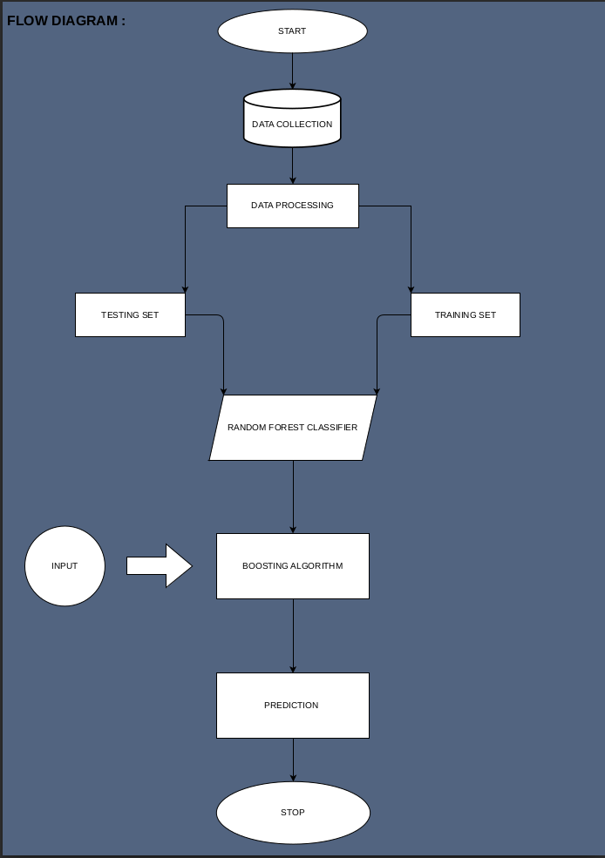
Exploratory Data Analysis
The following figure(Fig:1) shows the correlation between the 11 selected features
and the dependent variable is collision severity.

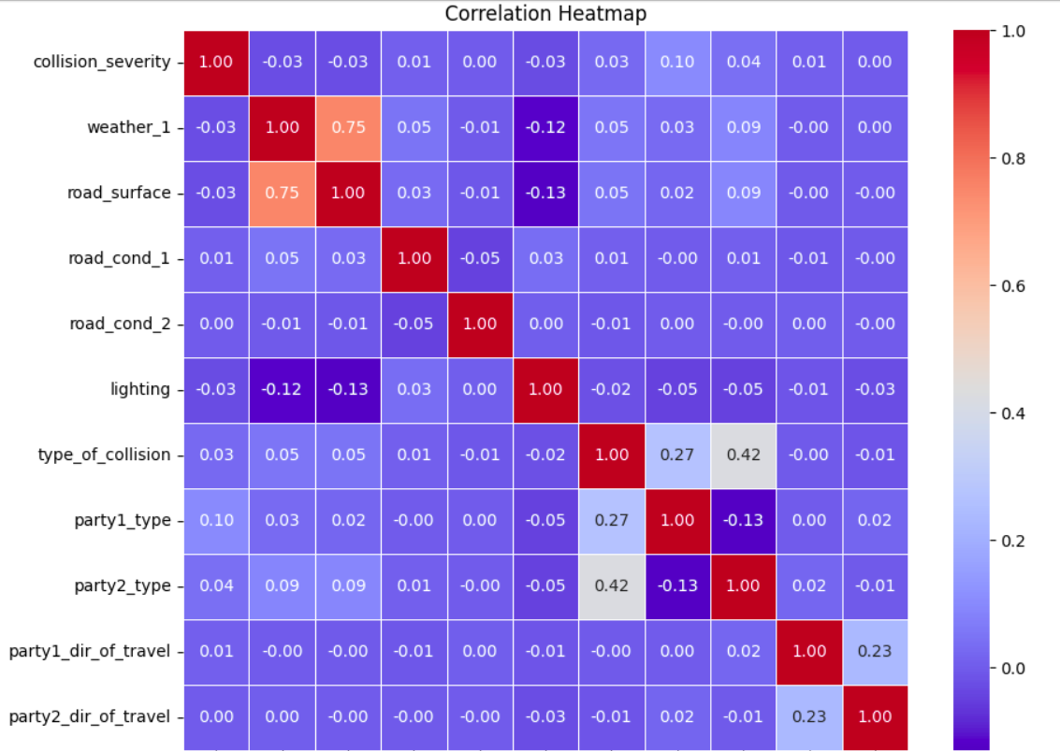

Fig 1: Heat-map showing correlation among selected features.

The following figure(Fig:2) shows the data imbalance in the given dataset, among the classes in dependent feature. We have made a binary classification model by merging four classes into two, so as to meet the requirement of a typical Binary classifier.

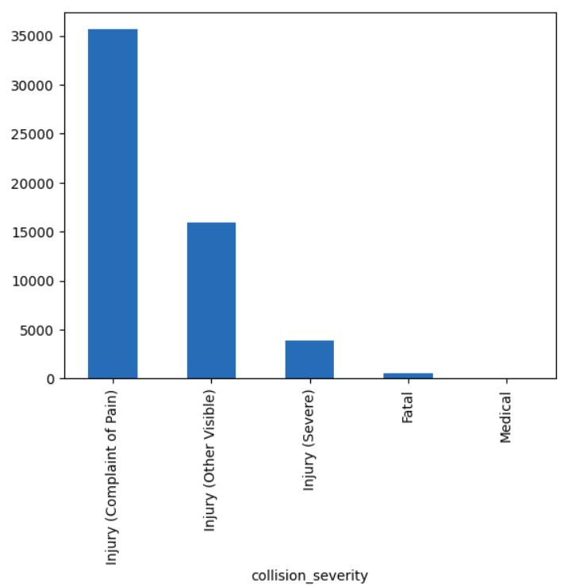
Fig 2: Data Imbalance

The following figure (Fig:3) shows us the relation between the lighting feature and the collision severity. One can get the correlation among lighting and dependent variable from the following figure.
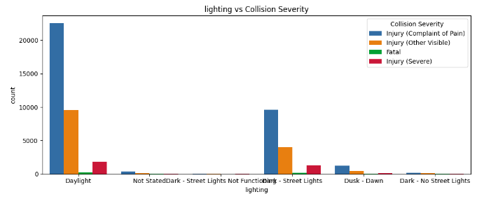
Fig 3: Lighting vs Collision Severity

The following figure 4, shows us the relation between the weather condition influencing the collision severity plotted as weather vs collision severity.

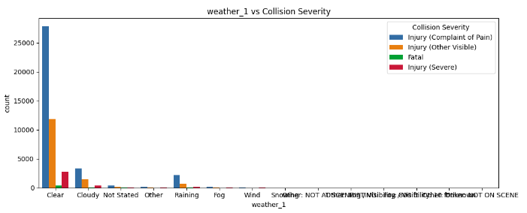
Fig 4: Weather Condition vs Collision Severity

The figure below indicates the graph plotted between road condition on the time of collision versus the severity of collision. It can be seen that the most collisions happened when there is usual/normal roadways.
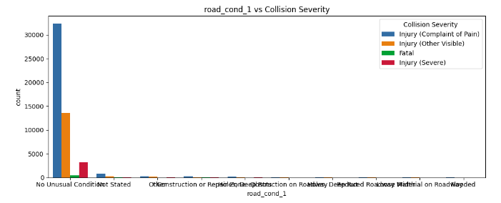
Fig 5: Road Conditions vs Collision Severity

The figure below shows us collision severity based on the type of collision. We can conclude by the observation that Road-side and Near-End collisions contribute the most part.

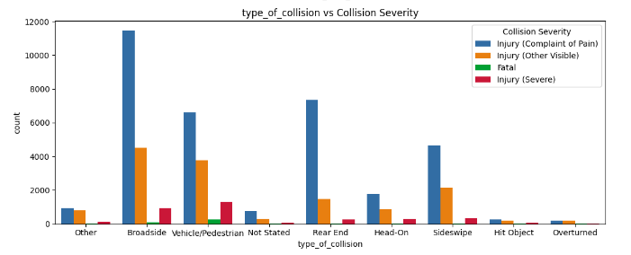

Fig 6: Type of Collisions vs Collision Severity

The below figure 7 shows us the graph of Assailant type and severity it impacted on the victim. This graph infers that the vehicle running has recorded the most number of accidents.

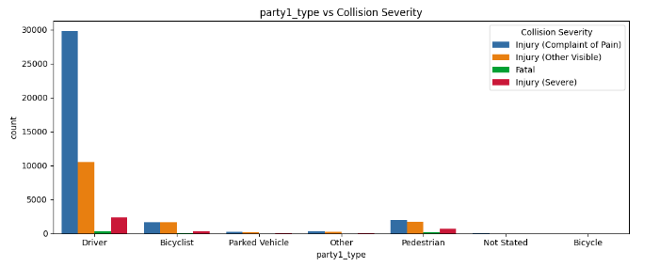
Fig7: Assailant Type vs Collision Severity

Results and discussion:
SVM, KNN, Logostic Regression, Naive-Bayes, Random Forest, Decision Tree and Gradient Boosting machine learning algorithms were used to predict the classification of the severity as Fatal and Non-Fatal. Among the given algorithms, Random Forest algorithm was the best performing one as it provided the highest F1 score of 0.73.

def evaluate_model(model):
y_true = y_test
y_pred = model.predict(x_test)
accuracy = accuracy_score(y_true, y_pred)
precision = precision_score(y_true, y_pred, average = 'micro')
recall = recall_score(y_true, y_pred, average = 'micro')
f1 = f1_score(y_true, y_pred, average = 'micro')
return accuracy, precision, recall, f1

Accuracy: 75.73
Precision: 71.35
Recall: 73.24
F1: 73.00

GUI:
GUI is made using Flask framework. Flask is a micro web framework written in Python. It is classified as a microframework because it does not require particular tools or libraries. It has no database abstraction layer, form validation, or any other components where pre-existing third-party libraries provide common functions. However, Flask supports extensions that can add application features as if they were implemented in Flask itself. Extensions exist for object-relational mappers, form validation, upload handling, various open authentication technologies and several common framework related tools

6.GitHubLink:

7. Future Work and Conclusion

7.1 Future Work
Ongoing Model Improvement: Continued efforts will be directed towards enhancing the machine learning model for predicting vehicle collision severity. Future work may include:
- Feature Engineering:
  - Exploration of additional features or feature combinations that could contribute to improved model performance.
  - Iterative refinement of existing features based on ongoing analysis and feedback.
- Algorithm Exploration:
  - Investigation into alternative machine learning algorithms to assess their suitability for the specific task.
  - Comparative studies to identify the most effective algorithm for the given dataset.
- Data Augmentation:
  - Exploration of techniques for augmenting the dataset, potentially addressing imbalances or improving model generalization.
  - Investigation into synthetic data generation to diversify the training set.

- Hyperparameter Tuning:
  - Further optimization of hyperparameters to fine-tune the model and improve its predictive capabilities.
  - Utilization of advanced optimization techniques or automated hyperparameter tuning tools.
- Feedback Loop:
  - Establishment of a feedback loop with end-users, stakeholders, or domain experts to incorporate real-world insights and continuously refine the model.
Expansion of Features:
- Consideration of additional features related to environmental conditions, driver behavior, or road infrastructure.
- Integration of real-time data sources for dynamic and up-to-date predictions.
Deployment in Real-world Scenarios:
- Extensive testing and validation for deploying the model in real-world scenarios, potentially in collaboration with transportation authorities or relevant organizations.
- Integration with existing traffic management systems for enhanced decision support.

7.2 Conclusion
Key Achievements:
- The development of a robust machine learning model for predicting vehicle collision severity based on historical data.
- Successful implementation of a user-friendly graphical user interface (GUI) to make the model accessible to a wider audience.
Contributions:
- Insights gained from exploratory data analysis shed light on the factors influencing collision severity.
- The Random Forest Classifier demonstrated commendable performance in predicting severity levels.
Significance:
- The project contributes to the field of transportation safety by providing a tool for predicting collision severity, aiding in proactive measures and efficient resource allocation.

Challenges and Learnings:
- Challenges encountered during model development and evaluation provided valuable insights.
- Continuous learning and adaptation to evolving requirements and feedback.
Acknowledgments:
- Recognition of contributions from team members, stakeholders, and collaborators who played a role in the project's success.
Closing Remarks:
- A note expressing gratitude, summarizing the project's journey, and looking forward to future advancements and collaborations.
The Future Work and Conclusion section encapsulates the project's trajectory, acknowledging accomplishments, detailing plans for future enhancements, and expressing a positive outlook for the ongoing evolution of the model and its real-world impact.

